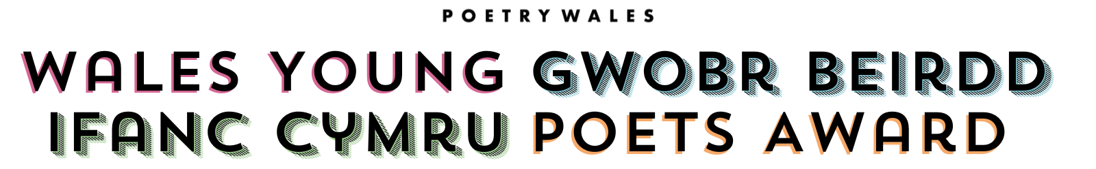

Originally launched in 2020 during the COVID-19 global pandemic to support young poets aged 10-17, Wales Young Poets Award is a competition for the next generation of UK-based poets writing in both English and Welsh

Our theme for 2023 is Peace, which poets are encouraged to interpret in any way they choose. We are working together with the Wales Centre for International Affairs Peace Schools Scheme to provide resources and support for discussing and exploring this theme

We have lesson plans and teaching exercises on the subject of ‘Peace’ by Alex Wharton (current Wales Children’s Laureate Wales) and Connor Allen (Wales Children’s Laureate 2021-23), as well as other poetry teaching resources available on our website

Our judge for 2023 is Eurig Salisbury, who is a poet and novelist. He has published two collections of poetry, Llyfr Glas Eurig (2006) and Llyfr Gwyrdd Ystwyth (2020). He was Bardd Plant Cymru (Welsh children’s laureate) 2011–13, and a Hay Festival International Fellow 2012–13. He won the Prose Medal at the National Eisteddfod of Wales in 2016 with his first novel, Cai, and published his first novel for young adults, Ifor Bach, in 2019. With Aneirin Karadog, he presents and produces a monthly podcast about Welsh poetry called Clera. He is Assistant Head and Lecturer in Creative Writing in the Department of Welsh and Celtic Studies at Aberystwyth University. In 2023, Eurig was appointed the first Town Poet in Aberystwyth. He judged our 2020 competition and edited the winners anthology, Land of Poets

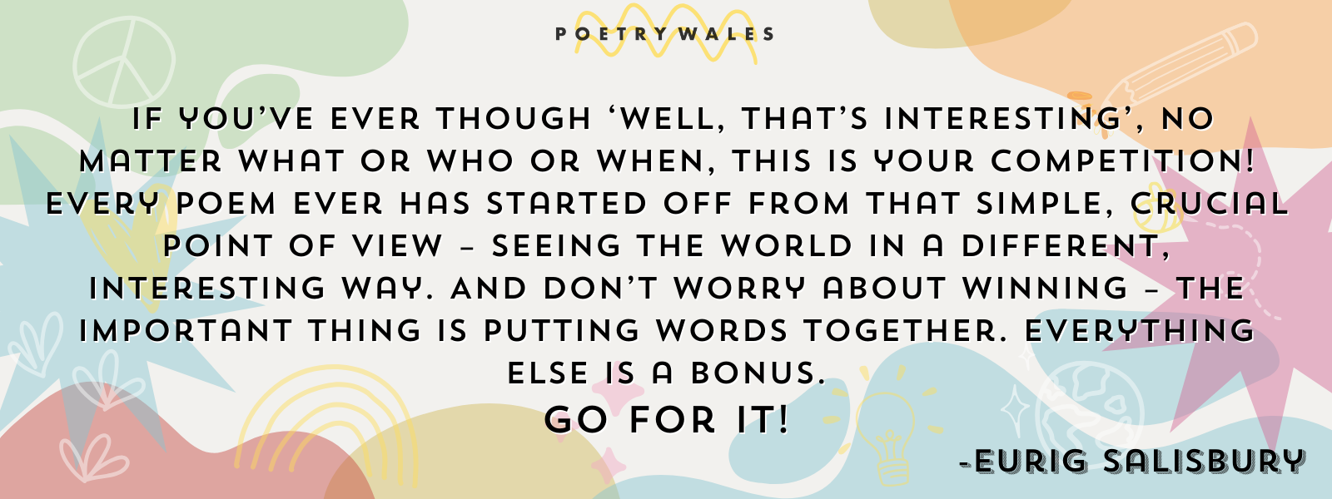

Prizes
Judging will be split into four categories:
- English Language 10-13
- English Language 14-17
- Welsh Language 10-13
- Welsh Language 14-17

For each of these categories there will be the following prizes:
- 1st Prize | £50 worth of National Book Tokens, writing goodie bag and publication
- 2nd Prize | £30 worth of National Book Tokens, writing goodie bag and publication
- 3rd Prize | £15 worth of National Book Tokens, writing goodie bag and publication
- 10-15 highly commended poets will be published in our anthology

How to Enter
Poems can be entered either as an individual or by teachers or educators/caregivers for a group of students
Before entering your poems, please make sure you have read and understood the rules below
Rules:
- Wales Young Poets Award opens for entries 10th July 2023 and closes 29th February 2024
- The competition is open to poets aged 10-17 living in the UK at the time of submission
- Poems can be sent in Welsh or English and must be inspired by the theme ‘Peace’
- Each entry must be accompanied by a form (available to download below), and every entrant can submit a maximum of 2 entries in either language
- If you have a performance poem you would like to submit, ask your parent/guardian’s permission to send it us. Please attach it to your email with the written version of your entry, your entry form, and your parent/guardian’s details to confirm we have their permission. This applies to anyone sending video entries aged 13-17
- For those aged 13 and under, poems should be submitted on their behalf of from a teacher, parent or guardian
- We cannot accept poems that have been published before or submitted to another writing competition
- Entries will not be returned so please keep a copy for your own records
- Poems may not be edited or changed once they have been submitted
- Entries should be typed in a legible font. Arial size 12 is ideal
- Prizes may not be awarded if we do not receive a minimum of 50 entries
- Each poem must be sent as an attached Word document (.doc or .docx file)
- By entering Wales Young Poets Award, authors of winning and highly commended poems grant Poetry Wales Press Ltd. the unrestricted rights in perpetuity (forever!) to publish and broadcast their poem in print, online, audio and video
- Winning and highly commended poems will be collected in a print anthology which will be distributed to school libraries and sold

Entering:
Poems can be entered by Google Form, email, or post. Entries can be made by individuals or on behalf of a group of poets by a teacher/caregiver. Make sure you have chosen the correct form for you.

For those aged 13 and under, poems should be submitted on their behalf of from a teacher, parent or guardian

Links

Web page in English

Web page in Cymraeg

Google Form for individuals

Google Form for Groups

Teaching Resources

Previous anthology

